**RIP V2 Topology (Set – A)**

|  |  |
| --- | --- |
| **Name: Devopriya Tirtho** | **ID: 160204033** |

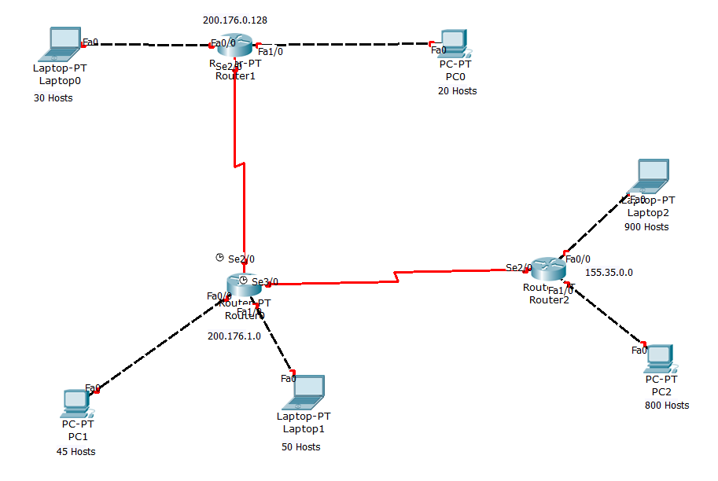

**Addressing Table**

|  |  |  |  |  |
| --- | --- | --- | --- | --- |
| **Device** | **Interface** | **IP Address** | **Subnet Mask** | **Default Gateway** |
| **PC0** | **N/A** | **200.176.0.130** | **255.255.255.224** | **200.176.0.129** |
| **PC1** | **N/A** | **200.176.0.162** | **255.255.255.224** | **200.176.0.161** |
| **PC2** | **N/A** | **200.176.1.2** | **255.255.255.192** | **200.176.1.1** |
| **PC3** | **N/A** | **200.176.1.66** | **255.255.255.192** | **200.176.1.65** |
| **PC4** | **N/A** | **155.35.0.2** | **255.255.252.0** | **155.35.0.1** |
| **PC5** | **N/A** | **155.35.4.2** | **255.255.252.0** | **155.35.4.1** |
| **R0** | **Fa0/0** | **200.176.1.1** | **255.255.255.192** | **N/A** |
|  | **Fa1/0** | **200.176.1.65** | **255.255.255.192** | **N/A** |
|  | **Se2/0** | **20.1.1.2** | **255.255.255.252** | **N/A** |
|  | **Se3/0** | **20.2.2.1** | **255.255.255.252** | **N/A** |
| **R1** | **Fa0/0** | **200.176.0.129** | **255.255.255.224** | **N/A** |
|  | **Fa1/0** | **200.176.0.161** | **255.255.255.224** | **N/A** |
|  | **Se2/0** | **20.1.1.1** | **255.255.255.252** | **N/A** |
| **R2** | **Fe0/0** | **155.35.0.1** | **255.255.252.0** | **N/A** |
|  | **Fe1/0** | **155.35.4.1** | **255.255.252.0** | **N/A** |
|  | **Se2/0** | **20.2.2.2** | **255.255.255.252** | **N/A** |

**Configuring RIPv2**

|  |  |
| --- | --- |
| **Device** | **Command** |
| **R0** | Router(config)#router rip  Router(config-router)#version 2  Router(config-router)#network 200.176.1.0  Router(config-router)#network 200.176.1.64  Router(config-router)#network 20.1.1.0  Router(config-router)#network 20.2.2.0  Router(config-router)#no auto summary  Router(config-router)#exit |
| **R1** | Router(config)#router rip  Router(config-router)#version 2  Router(config-router)#network 200.176.0.128  Router(config-router)#network 200.176.0.160  Router(config-router)#network 20.1.1.0  Router(config-router)#no auto summary  Router(config-router)#exit |
| **R2** | Router(config)#router rip  Router(config-router)#version 2  Router(config-router)#network 155.35.0.0  Router(config-router)#network 155.35.4.0  Router(config-router)#network 20.2.2.0  Router(config-router)#no auto summary  Router(config-router)#exit |